**Node.js**

Node.js is an open source server environment which is free. It runs on various platforms such as Windows, Linux, Unix, Mac OS X, and others. Node.js uses an Asynchronous programming method. Some common tasks for a web server is to open files on the server and return the content to the client. Node.js handles file requests wherein it sends the task to the computer’s file system, then handles the next request. When the file system has opened and read the files, it returns the content to the client. Node.js is a single-threaded, non-blocking, asynchronous program which is very memory efficient and this eliminates waiting and is simply continuous with the next request. Node.js can generate dynamic page content and also open, read, write, delete, and close files in the server. It also collects data which can be added, deleted, or modified in one’s database. A Node.js file contains the tasks that will be executed in certain events for example; someone is accessing a port on the server. The files must be initiated in the server before having its purposed effect. A brief history of JavaScript is that, in the year 1995, a contractor to Netscape named Brendan Eich created the JavaScript Language in order to run web browsers. It was initially intended to have enabled animations and other manipulations of a browser’s document object model or DOM. Shortly afterwards a version of JavaScript for the Netscape Enterprise Server was introduced. The name of JavaScript was chosen for the marketing purposes because of the Sun’s Java language was a widely famous at that time. JavaScript was based primarily on the scheme and self-languages together with superficial Java-like semantics.

In the year 2009, the JavaScript-based Node.js platform was introduced by Ryan Dahl for the Linux and Mac OS as an alternative to Apache HTTP Server. The high level Node.js combines the Google V8 JavaScript engine.

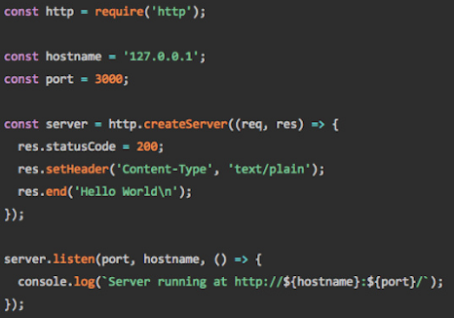The stripped-down example code :

This code shows the basic HTTP server pattern that uses ES6 arrow functions with anonymous Lambda functions and declared by using the fat arrow “=>” operator for callbacks.